**LAB REPORT 6**

**Name:- Ayush Kumar Gupta**

**ROLL NO:- 2023114001**

**1.OBJECTIVE –** To use 7 segment display to count from 0-9.

**ELCTRONIC COMPONENTS REQUIRED -**

1. 74HC93 IC(4-bit Binary Ripple Counter)
2. CD4511 IC(7-Segment Deecoder)
3. 7 Segment Display
4. Digital Circuit

**PROCEDURE:**

1. Test the ICs, LED Lights and Switches.
2. Connect ICs with GND, Power.
3. ­­­­­­­Connect the circuit as given in reference circuit.
4. A circuit diagram of a device

   Description automatically generated
5. Check the output with following order.

Conclusion:

If Connected with Common Cathode, Output will be inverted. But all numbers will be printed.

**LINK FOR TINKERCAD SIMULATION :**

[**https://www.tinkercad.com/things/6bbZwuEUB6y-clock-boom/editel?sharecode=b5ub_SjX-GWVJHo4Q4lh2TGP0I-m52XufVJBFxGeels**](https://www.tinkercad.com/things/6bbZwuEUB6y-clock-boom/editel?sharecode=b5ub_SjX-GWVJHo4Q4lh2TGP0I-m52XufVJBFxGeels)

**TINKERCARD :**

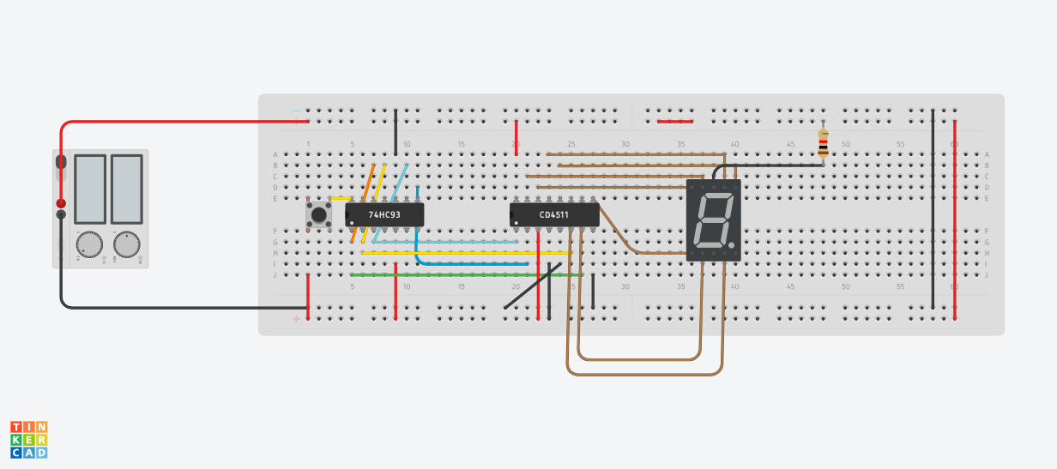

LAB:

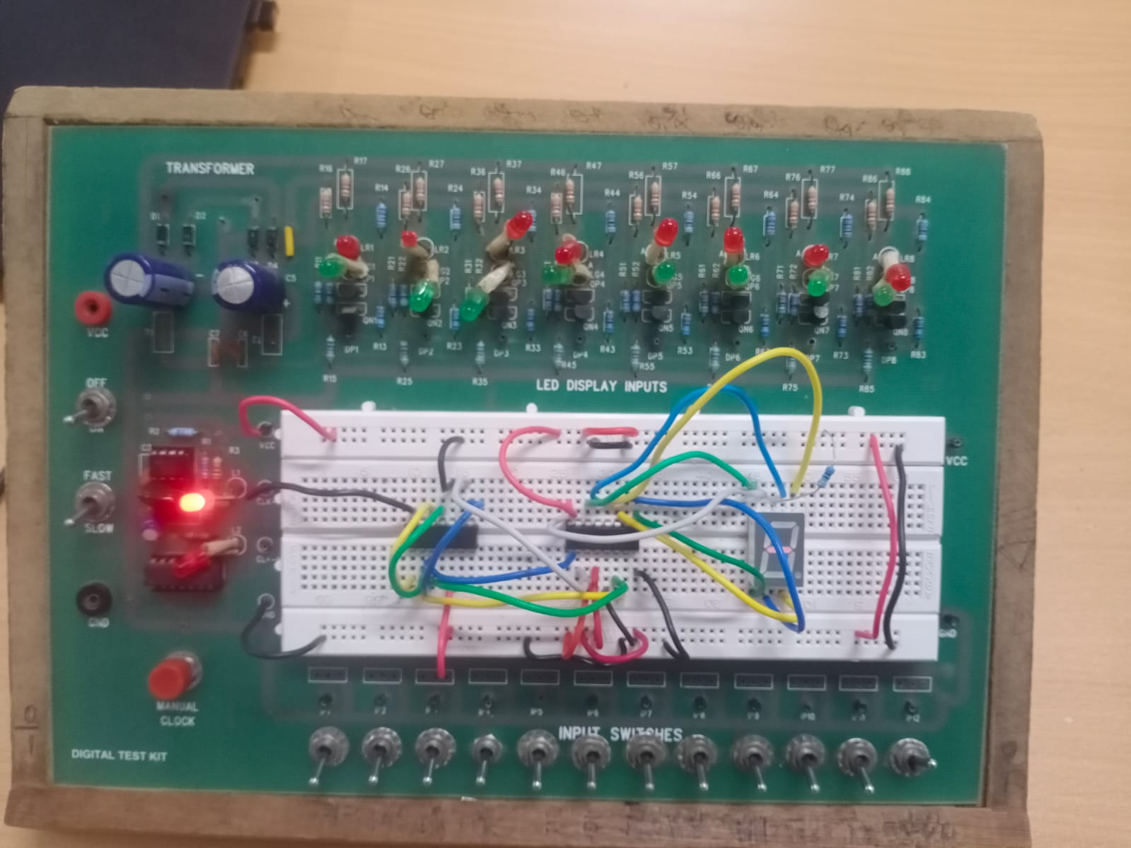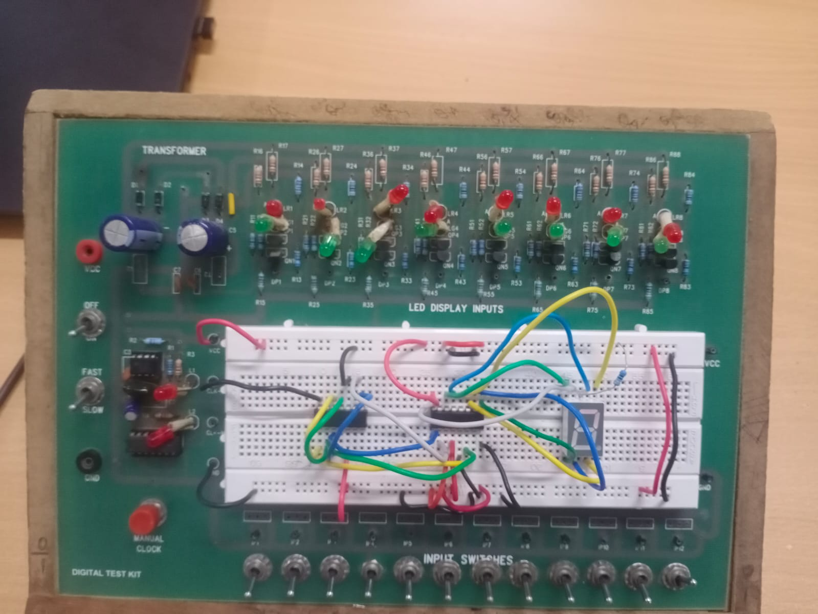

**2.A. OBJECTIVE –**To Form Counter from 0 to 255 with Shift Register .

**ELCTRONIC COMPONENTS REQUIRED –**

1. Digital test kit.
2. Shift Register.
3. Arduino UNO

**PROCEDURE:**

* Test the ICs, LED Lights.
* Connect ICs with GND, Power.
* ­­­­­­­Connect the circuit as given in reference circuit.
* Connect the prescibed pins as given in picture to arduino,(For Code).

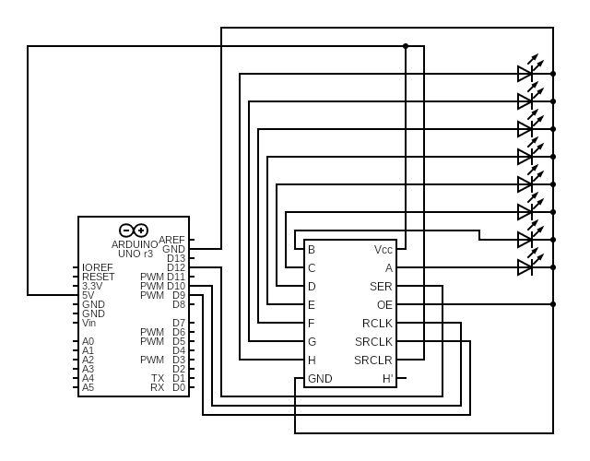

Conclusion:

Number From 0 to 255 got printed using given Code. Red for 1 and Green for 0.

**LINK FOR TINKERCAD SIMULATION :**

[**https://www.tinkercad.com/things/9JkArG4R8tl-countinginbinary/editel?sharecode=onNoL4wSfuGEZ-rTAMWpyYu6SRt0PMl41rbtVFL_iYE**](https://www.tinkercad.com/things/9JkArG4R8tl-countinginbinary/editel?sharecode=onNoL4wSfuGEZ-rTAMWpyYu6SRt0PMl41rbtVFL_iYE)

**TINKERCARD :**

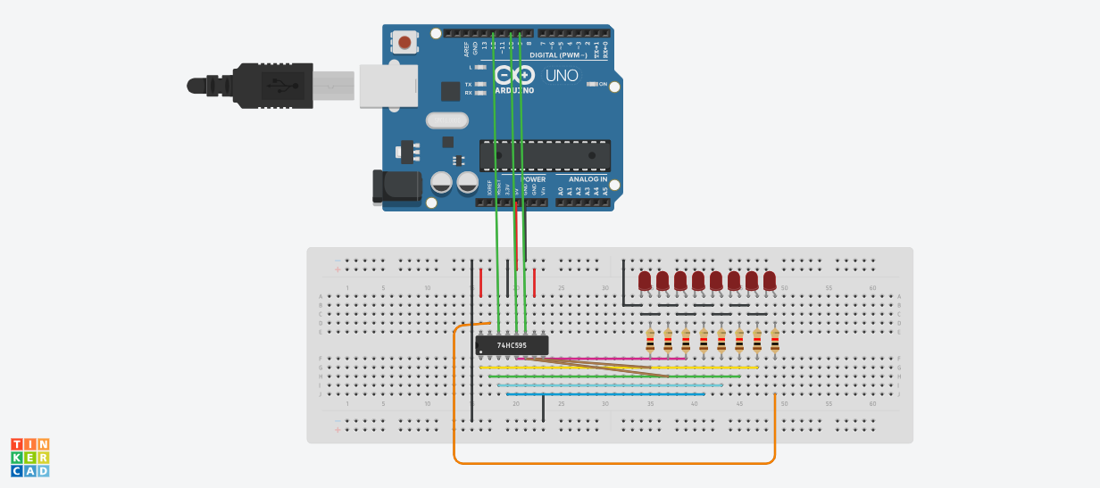

**CODE :**

**// C++ code**

**//**

**int input=12,ORegClk=10,ShiftRegClk=9;**

**void setup()**

**{**

**pinMode(input, OUTPUT);**

**pinMode(ORegClk, OUTPUT);**

**pinMode(ShiftRegClk, OUTPUT);**

**}**

**void loop()**

**{**

**for(int i=0;i<256;i++){**

**digitalWrite(ORegClk, LOW); //Clock which changes from HtoL to register data in SR.**

**shiftOut(input,ShiftRegClk,MSBFIRST,i);**

**digitalWrite(ORegClk, HIGH);**

**delay(500);**

**}**

**}**

**2.B. OBJECTIVE –**To Glow mentioned number bulb.

**ELCTRONIC COMPONENTS REQUIRED –**

1. Digital test kit.
2. Shift Register.
3. Arduino UNO

**PROCEDURE:**

* Test the ICs, LED Lights.
* Connect ICs with GND, Power.
* ­­­­­­­Connect the circuit as given in reference circuit.
* Connect the prescibed pins as given in picture to arduino,(For Code).



Conclusion:

When We Enter the number, Its numbered Bulb glows.

**LINK FOR TINKERCAD SIMULATION :**

[**https://www.tinkercad.com/things/c1ftqVywF6L-thebulbpointer/editel?sharecode=d4YgDGR7oMc3urb27h_6KkRxB1dJtla0bJKloUsbgwg**](https://www.tinkercad.com/things/c1ftqVywF6L-thebulbpointer/editel?sharecode=d4YgDGR7oMc3urb27h_6KkRxB1dJtla0bJKloUsbgwg)

TinkerCad:



LAB:

**CODE :**

// C++ code

//

int input=12,ORegClk=10,ShiftRegClk=9;

int led;

void setup()

{

pinMode(input, OUTPUT);

pinMode(ORegClk, OUTPUT);

pinMode(ShiftRegClk, OUTPUT);

Serial.begin(9600);

}

void loop()

{

Serial.print("LED Number=");

led= Serial.read();

led=led-'0';

Serial.println(led);

int x=1;

for(int i=0;i<led;i++){

x=x*2;

}

digitalWrite(ORegClk, LOW); //Clock which changes from HtoL to register data in SR.

shiftOut(input,ShiftRegClk,MSBFIRST,x);

digitalWrite(ORegClk, HIGH);

delay(2000);

}